**Experiment 2: Dual LED Chaser**

**Aim:** Design a Dual LED Chaser.

**Apparatus:** LEDs, Resistances (470 ohm), Breadboard, Arduino, wires.

**Circuit Diagram:**

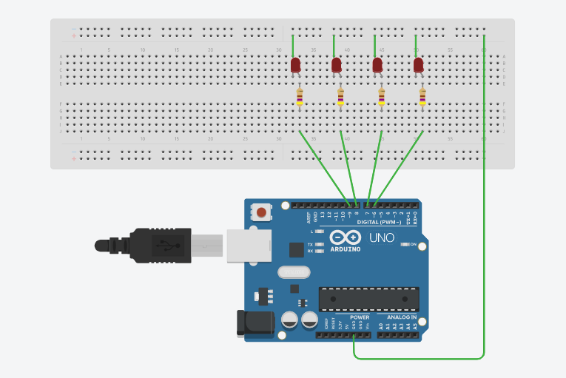

**Theory:**

1. Concept Used:
2. In Arduino, digital pins provide input as well as output but analog pins only provide input.
3. Resistance is used in series with LEDs to oppose current so that excess current may not damage LED.
4. Current flows from anode to cathode and not in reverse direction through LEDs.
5. Learning & Observations:
6. Learn to Join LEDs in parallel.
7. All anode parts of LEDs are connected to digital pins of Arduino.
8. Learn about different parts of Arduino and how to use them.
9. All LEDs are ending at a single point before connecting to Arduino.

**Problems and Troubleshooting:**

1. Using ‘for’ loop. It is solved by learning basics about ‘for’ loop.

**Precautions:**

1. Connections should be made carefully and clearly.
2. We should use resistance so that excess current may not damage any LED.
3. ‘for’ loop and ‘If-else’ should be used carefully.
4. LEDs should be checked before using in circuit whether it is working or not.
5. Give some delay time between ‘on’ and ‘off’ states of LED to distinguish.

**Learning Outcomes:**

1. Using Arduino for making different kinds of LED patterns.
2. Using ‘for’ loop and ‘if-else’ properly.
3. Defining new functions like void allLEDsOff (void).
4. Using Arduino and defining output pins.
5. How connections are made inside a breadboard.
6. Using void setup and void loop.

**Result:** LEDs chasing is observed after running Arduino.